Template Board Charter

Context
The Sports Governance Principles specify that an organisation should clearly define and document its structure and the duties, responsibilities and powers of members, directors, committees and management.

Background
The purpose of a board charter is to clearly define the respective roles, responsibilities and authorities of the board of directors (both individually and collectively) and management in setting the direction, the management and the control of the organisation.

Although the specific circumstances and environment of each sporting organisation will differ, this template is suggestive of the sorts of matters that may be included but should not be seen as required or exhaustive. The charter should be reviewed in line with the organisation’s constitution and amended accordingly. The board should lead the process of updating and tailoring the content to ensure the final document reflects their own environment and can play an active part in strengthening the culture and governance of their specific organisation.

How to use this document
- This document has been designed as a template. Fields highlighted in yellow should be filled out with the information relevant to your organisation.
- Please note that this guidance and template are general in nature and must be tailored to the requirements of your sporting organisation.
- This document does not constitute legal advice and should not be relied upon as legal advice. We recommend seeking further professional advice should you have any specific queries.

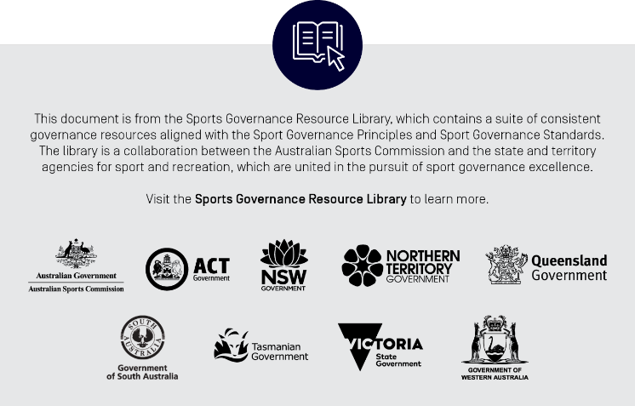

[Insert sporting organisation]

Board Charter

- Purpose of this Charter
  - The Board Charter sets out the role, composition and responsibilities of the Board of Directors (“the Board”) of X SO
  - The conduct of the Board is also governed by the Constitution of X SO, a copy of which is located at web address
A number of operational Board matters such as number of meetings per year, election and appointment processes and member meetings are governed by the Constitution and are not reproduced here.
- Roles and Responsibilities
  - The Board’s key responsibilities are:
    - to act in the best interests of the X SO as a whole;
    - observe their duties as Directors in terms of the Corporations Act 2001 (Cth), common law, the X SO constitution and any other relevant legislation; and
    - provide strategic direction for X SO and effective oversight of Management.
  - The key functions of the Board are to:
    - Provide effective leadership and collaborate with the executive management team in:
    - articulating the organisation’s values, vision, mission and strategies
    - developing strategic plans and ordering strategic priorities
    - maintaining open lines of communication and promulgating through the organisation and with external stakeholders the values, vision, mission and strategies
    - developing and maintaining an organisation structure to support the achievement of agreed strategic objectives
    - Ensuring a diverse and effective Board, in line with the X SO constitution with appropriate policies and procedures for the Board and its committees;
    - Appointing, supporting and providing advice and counsel to, evaluating and rewarding the CEO against agreed performance indicators
    - Monitor the achievement of the strategic and business plans and annual budget outcomes
    - Supporting, reviewing and monitoring the operational and financial performance of X SO;
    - Establish such committees, policies and procedures as will facilitate the more effective discharge of the Board’s roles and responsibilities
    - Ensure, through the Board committees and others as appropriate, compliance obligations and functions are effectively discharged
    - Ensure that all significant systems and procedures are in place for the organisation to run effectively, efficiently, and meet all legal and contractual requirements
    - Monitoring key financial and non-financial risk areas by ensuring the implementation of an effective risk management and internal control framework;
    - Ensure that organisation has appropriate corporate governance structures in place including standards of ethical behaviour and promoting a culture of corporate and social responsibility;
    - Managing Directors’ interests, conflicts of same and related-party transactions
    - Delegation of powers and authorities, while understanding the Board remains responsible for all decision of X SO;
    - oversight of compliance with appropriate laws and regulations and major litigation;
    - evaluating Board processes and performance of the Board as a whole, as well as contributions by individual Directors, ensuring the Board’s effectiveness in delivering good governance, including performance and conformance matters;
    - corporate governance matters, including frequency and agendas of Board and Committee meetings, and the appointment of the Company Secretary;
  - The Board has delegated authority for the operations and administration of the organisation to the Chief Executive Officer (CEO). The CEO is responsible for the overall day-to-day management and the performance of the Organisation. The CEO manages X SO in accordance with strategy, delegations, business plans and policies approved by the Board to achieve agreed goals and objectives included therein.
  - The Board has no operational involvement in the conduct of organisation’s business activities and delivery of services.
- Membership and Independence
  - The Constitution provides for a maximum of insert directors and a minimum of insert directors. The board requires a quorum of insert Directors to transact business at meetings.
  - Directors are free from any interest and any business or other relationship which could, or could reasonably be perceived to, materially interfere with the director’s ability to act in the best interests of the organisation.
  - The Board shall regularly assess the independence of each Director in light of the interests disclosed by them.
  - Each Director must provide the Board with relevant information to assess their independence.
  - In assessing independence, the following matters will be considered and a Director will be regarded as independent if that Director:
    - is a non-executive Director (i.e. is not a member of Management);
    - is not a director, officer or otherwise officially associated directly with a member or affiliated organisation;
    - has within the last three years not been a principal of a material professional adviser or a material consultant to X SO or an employee materially associated with the service provided;
    - has not been a material supplier of X SO, or an officer of or otherwise associated directly or indirectly with a material supplier;
    - has no material contractual relationship with X SO, other than as a Director of the Organisation;
    - has been free from any business relationship which could, or could reasonably be perceived to, interfere materially with the Director’s ability to act in the best interests of the Organisation.
  - Membership of the Board shall be disclosed in the annual report.
- Chair’s Responsibilities
  - The Chair of the Board has a major role as the head of the Board in providing leadership to the Directors and other functions including:
    - leading and facilitating the Board;
    - setting the Board direction and focus;
    - conducting an effective decision-making process and ensuring that the Board is focussed on achieving outcomes;
    - ensuring that no one has excessive influence;
    - maintaining a professional working relationship with the CEO;
    - acting as a spokesperson, where appropriate, in conjunction with the CEO;
    - promoting constructive and respectful relations between Directors;
    - ensuring the Board and individual Directors have a performance evaluation process;
    - ensuring that the Board’s workload is dealt with effectively;
    - role-modelling ethical standards and behaviour based on the X SO agreed values;
    - ensuring meetings are effectively conducted and minutes are circulated and acknowledged in a timely manner.
- Code of Conduct
  - X SO takes ethical and responsible decision-making very seriously. It expects its staff, volunteers and Directors to do the same.
  - All Directors must be bound by and at all times comply with the X SO Director Code of Conduct which outline the type of behaviour that X SO requires from its Directors and sets out clear principles and guidelines for the ethical and professional conduct of Directors in effectively carrying out their responsibilities.
  - The Board has an appropriate system for enforcing compliance with the code.
- Review of Charter
  - The Board will review this charter annually to ensure it remains consistent with the Board’s objectives and responsibilities.
- Publication of the Charter
  - Key features of the charter are to be outlined in the organisation Annual Report.
  - A copy of the charter is available at web address

