[Insert ORGANISATION Logo]

[INSERT ORGANISATION NAME]
RISK MANAGEMENT POLICY

Version: | 1.0
Date Adopted by [INSERT ORGANISATION NAME] Board: | [ ]
Effective Date: | [ ]
Review Frequency: | Annual
[Insert role title] is responsible for this document.

Template Instructions
- The Australian Sports Commission has developed a range of template documents that can be used by a Sport Insert Organisation Name to form a Risk Management Framework.

- This Template document should be read in conjunction with the ‘Risk Management Process Implementation Guide’ for Base Level Risk Maturity.
- This template can be used to outline the Sporting Organisation’s Risk Management Policy.

- A Risk Management Policy communicates the Sporting Organisation’s commitment and general approach to risk management, articulating its risk management objectives while describing how these objectives will be met. It should reflect the specific needs and nuances of the Sporting Organisation and should be reviewed and updated regularly (at least annually).

- Yellow highlighting within [ ] brackets indicates further information is required from the Sporting Organisation prior to finalising and adopting the template. Before finalising, insert relevant information where highlighted in yellow and delete these template instructions.

- DISCLAIMER: This template does not constitute legal advice. Sporting Organisations should take their own professional advice regarding the Risk Management Framework and each template document.

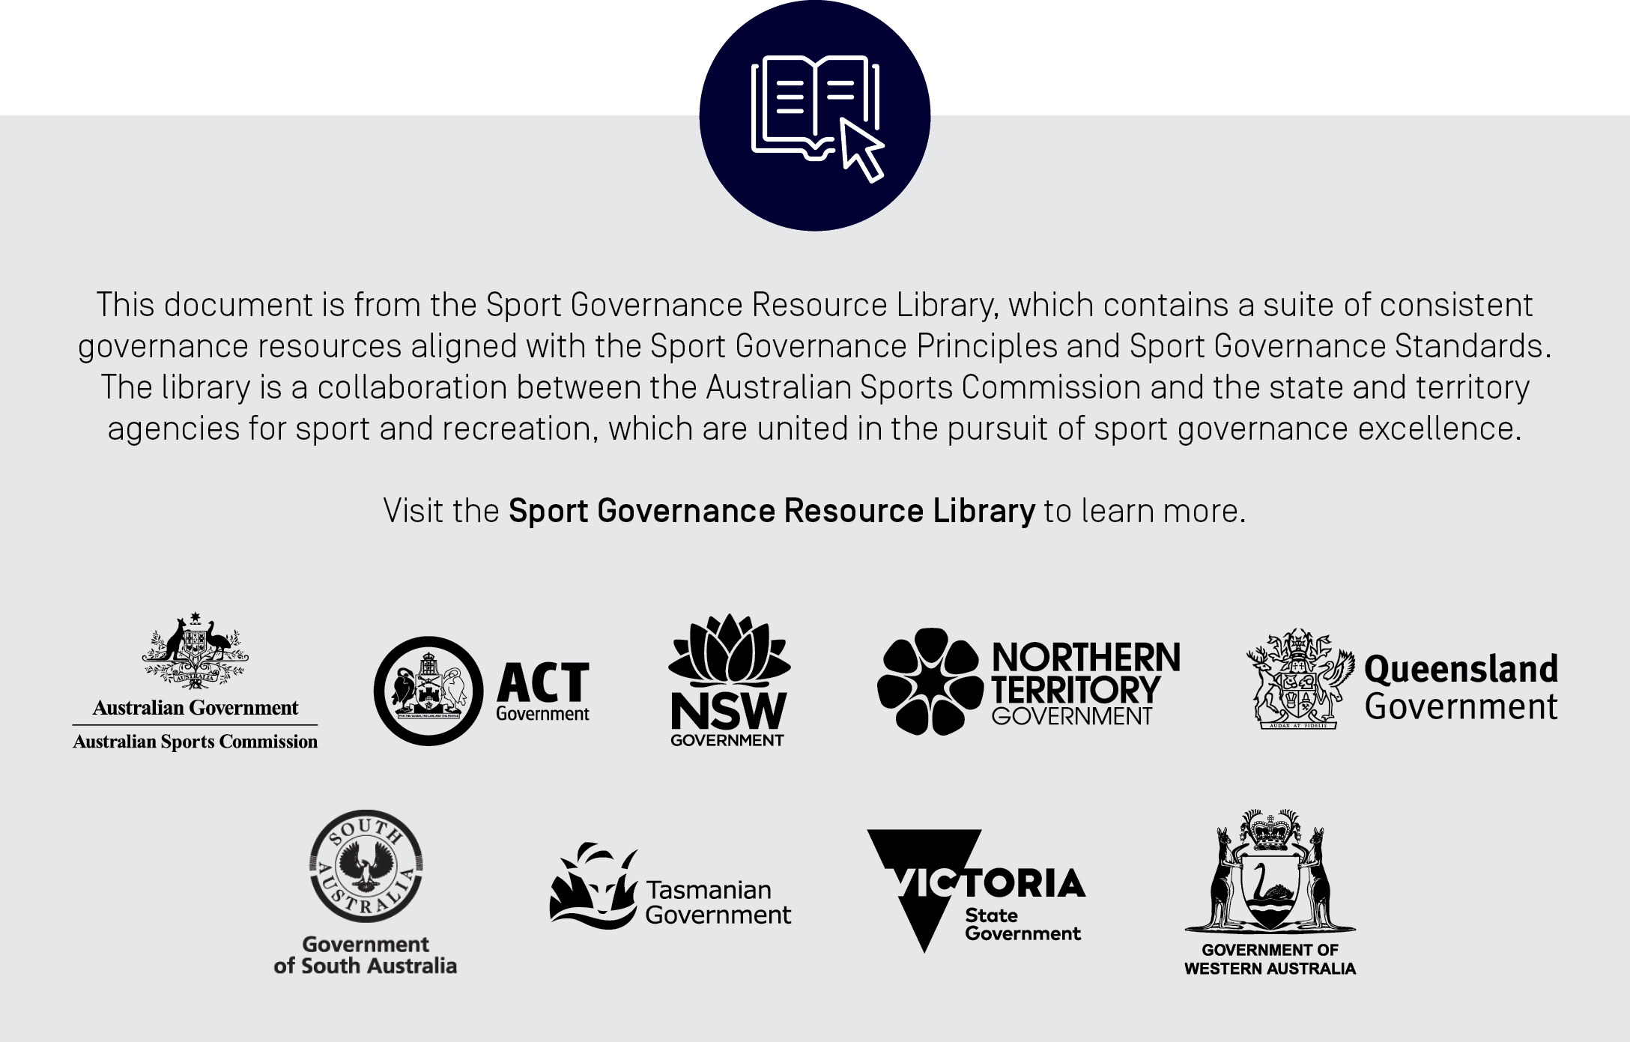

[INSERT ORGANISATION NAME] Risk Management Policy

[INSERT ORGANISATION NAME’s] vision is [insert].

[INSERT ORGANISATION NAME] acknowledges that risks are inherent in [all/most/some] aspects of [sport]. [INSERT ORGANISATION NAME] also acknowledges that it faces a variety of other risks related to the pursuit and delivery of its strategy and day-to-day operations. For these reasons, [INSERT ORGANISATION NAME] understands the importance of a structured and systematised approach to the identification and management of risks.

[INSERT ORGANISATION NAME] is committed to managing and minimising risk by identifying, analysing, evaluating and treating risks to ensure [INSERT ORGANISATION NAME] has the best prospects for achieving its strategic objectives and maintaining effective and efficient operations for the benefit of its [members, participants, fans and the broader community].

[INSERT ORGANISATION NAME] will regularly monitor, review and report on the effectiveness of its approach to risk management and aims to develop and maintain a risk aware culture. It will do this by adhering to the principles reflected in ISO 31000:2018 Risk Management – Guidelines as follows:

- Risk management activities are integral to [INSERT ORGANISATION NAME] and will be integrated across all [INSERT ORGANISATION NAME] areas and activities;
- [INSERT ORGANISATION NAME] will ensure a structured and comprehensive approach to risk management;
- [INSERT ORGANISATION NAME]’s approach to risk management will be customised and appropriate for the nature and scale of our organisation and the risks it faces;
- [INSERT ORGANISATION NAME] will be inclusive of relevant stakeholders to improve risk awareness and better inform its risk management efforts;
- [INSERT ORGANISATION NAME] will be dynamic in anticipating, detecting, acknowledging and responding to changing circumstances, events and the risk landscape;
- [INSERT ORGANISATION NAME]’s risk management efforts shall utilise the best available information and inputs, spanning historical, current and predictive information from all relevant and available stakeholders;
- [INSERT ORGANISATION NAME] acknowledges that human and cultural factors influence all aspects of risk management and will promote a risk aware culture; and
- [INSERT ORGANISATION NAME] will strive for continuous improvement in its risk management performance.

[INSERT ORGANISATION NAME] directors, officers and executives recognise and acknowledge their responsibilities for effective risk management. These include providing leadership and direction, allocating appropriate resources, monitoring and responding to information as it becomes available and encouraging a culture where speaking up and raising concerns is encouraged.

[insert signature]

[Insert CEO Name]
Chief Executive Officer
[Month Year]

