**[Insert ORGANISATION Logo]**

**[Insert ORGANISATION Name]**

**RISK APPETITE STATEMENT**

|  |  |
| --- | --- |
| **Version:** | 1.0 |
| **Date Adopted by [Insert Organisation Name] Board:** | [ ] |
| **Effective Date:** | [ ] |
| **Review Frequency:** | [Annual] |
| [Insert role title] is responsible for this document. | |

**Template Instructions**

1. The Australian Sports Commission has developed a range of template documents that can be used by a Sporting Organisation to form a Risk Management Framework.
2. This Template document should be read in conjunction with the *‘Risk Management Process Implementation Guide’* for Base Level Risk Maturity.
3. This template can be used to set out the Organisation’s Risk Appetite Statement.
4. A Risk Appetite Statement clearly articulates the amount and type of risk a Sporting Organisation is willing to take in pursuit of its strategic objectives. It articulates the Board’s risk appetite to assist management in their daily roles by establishing boundaries for sound decision making and risk taking. Developing a meaningful risk appetite requires a Board and Executive with sound and mature understanding of risk management. It can also be a time-consuming process involving significant consultation.
5. The risk appetite statements and ratings within this template are indicative only. Each Sporting Organisation should consider its own individual circumstances and select which risks apply, add sport-specific risks and modify risk appetite statements and the specific tolerances the Organisation is prepared to accept in relation to each risk. Statements should be reviewed on a regular basis.
6. Yellow highlighting within [ ] brackets indicates further information is required from the Sporting Organisation prior to finalising and adopting the template. Before finalising, insert relevant information where highlighted in yellow and delete these template instructions.
7. DISCLAIMER: This template does not constitute legal advice. Sporting Organisations should take their own professional advice regarding the Risk Management Framework and each template document.

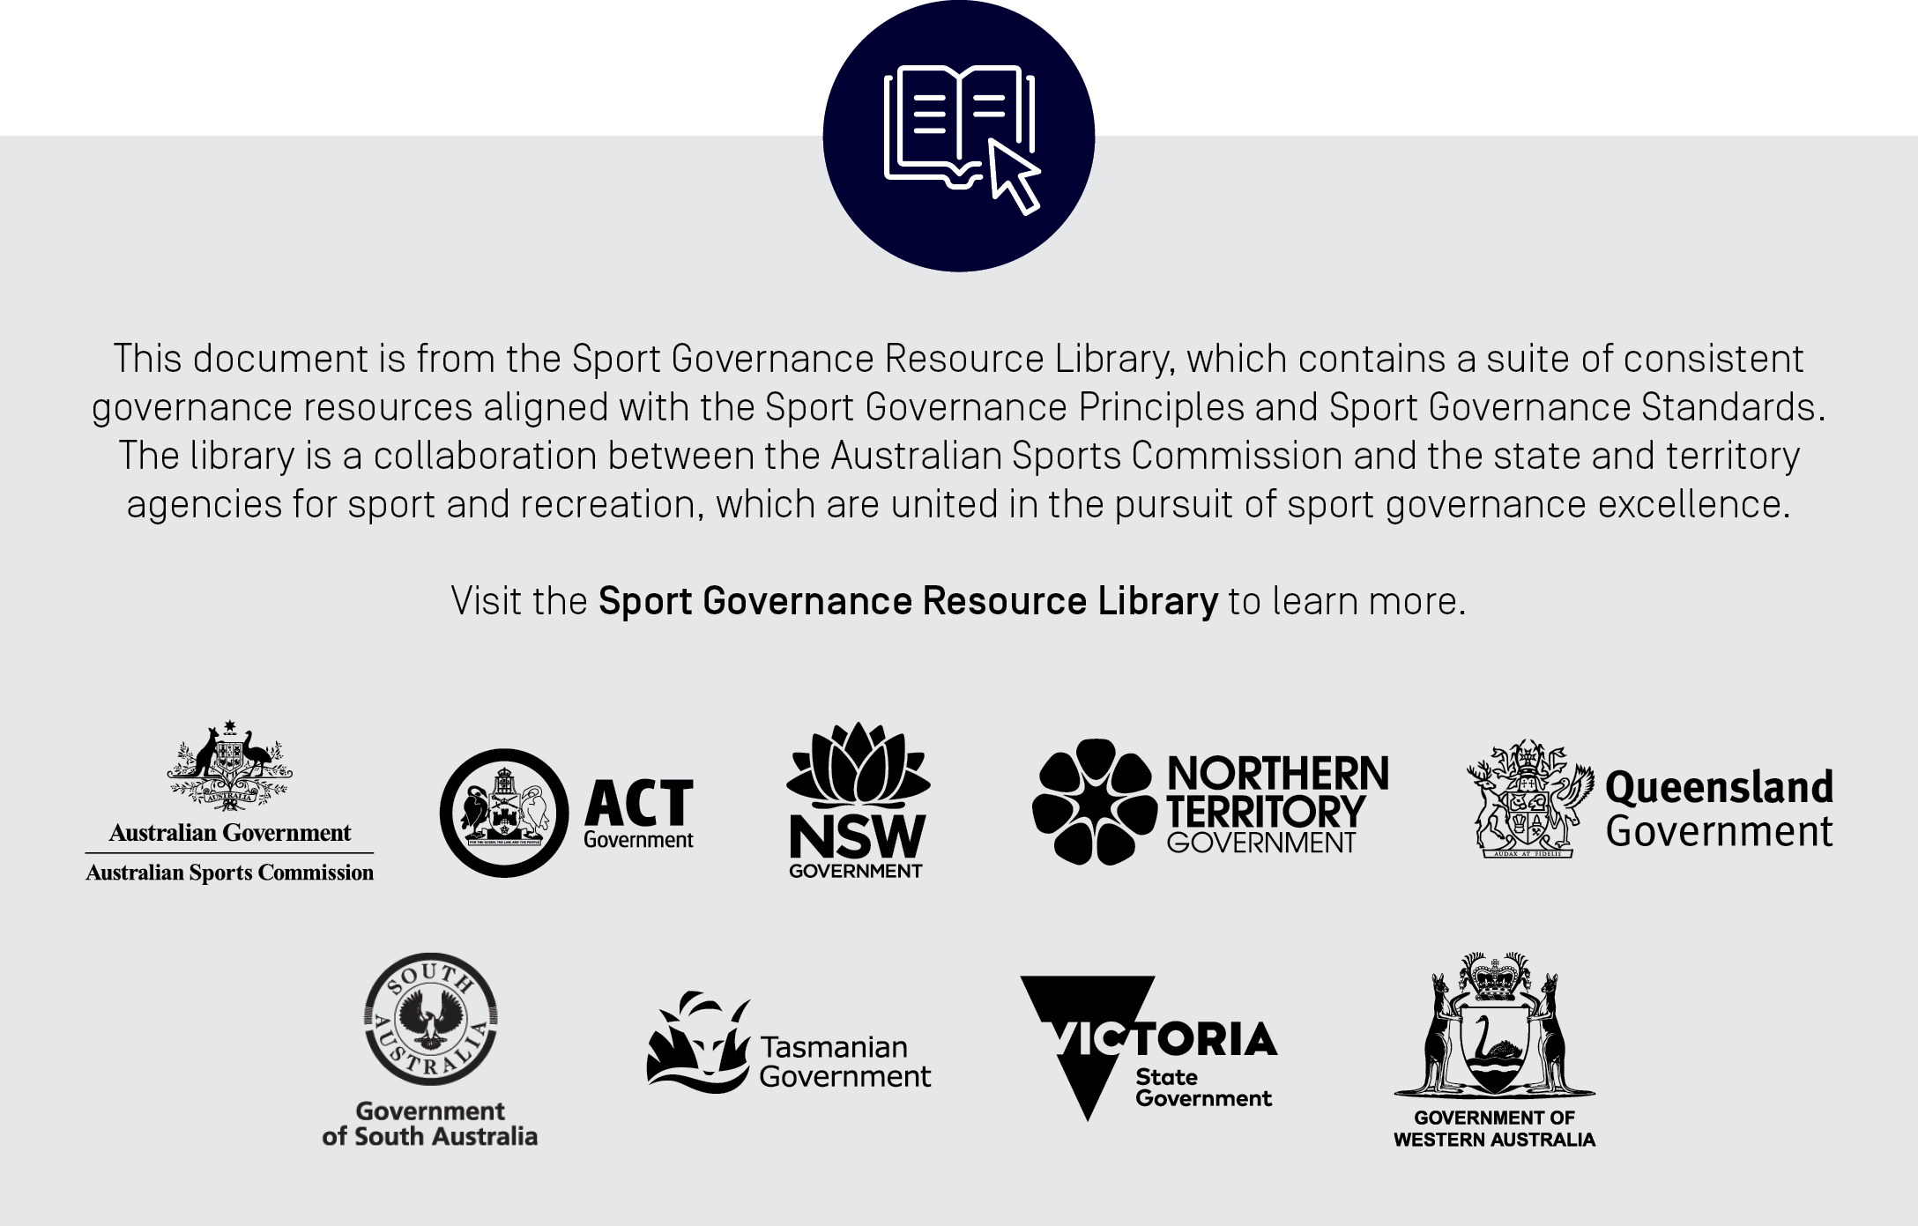

**[Insert ORGANISATION name] Risk Appetite Statement**

**1. Purpose**

The Board of Directors of [INSERT ORGANISATION NAME] acknowledges that, in pursuit of its strategic objectives, [INSERT ORGANISATION NAME] will face risks related to the following matters: [Board to select those which apply and add sport-specific and other key risks, such as environmental, social and corporate governance (ESG) risks.]

* [Health and safety;
* Child safety and safeguarding;
* Technology;
* Financial;
* Commercial;
* Cultural;
* Strategic;
* Reputational;
* Legal;
* Data security;
* Strategic; and
* High performance]

[INSERT ORGANISATION NAME] is committed to systematically and diligently managing these risks and emerging risks that may arise that have an impact on [INSERT ORGANISATION NAME]’s strategy and operations.

This Risk Appetite Statement describes [INSERT ORGANISATION NAME]’s approach to managing risk and provides the basis for setting acceptable levels of risk tolerance and identifying and implementing mitigation strategies. Risks residually rated as “Extreme” or “High” in [INSERT ORGANISATION NAME]’s Risk Assessment Matrix will be subject to careful and more regular Board and Management review and, where possible, will be managed down to a residual risk rating of “Medium” or “Low”.

**2. [INSERT ORGANISATION NAME] Strategic Objectives**

[INSERT ORGANISATION NAME should set out its strategic objective including its purpose, vision and values.]

**3. Risk Appetite Scale**

[INSERT ORGANISATION NAME] assesses its risk appetite in relation to particular risks using the follow risk appetite scale:

|  |  |  |
| --- | --- | --- |
| **Risk Appetite** | **Description** | **Rating** |
| **Zero tolerance** | Will avoid taking on any risk |  |
| **Low** | Organisational preference is to take caution and accept as little risk as reasonably possible (ALARP) |  |
|  |
| **Medium** | Takes a balanced view to risk taking |  |
|  |
| **High** | Willing to consider options having greater than normal inherent risk |  |
|  |
| **Extreme** | Willing to take on an aggressive level of risk taking |  |
|  |

**4. Risk Appetite Statements**

[Risk appetite statements and ratings are **examples and indicative only**. Organisations should consider its own individual circumstances and select which risks apply, add sport-specific risks and modify risk appetite statements and the specific tolerances the Organisation is prepared to accept in relation to each risk.]

[The rating for each risk appetite statement can be adjusted by capturing the arrow and moving it up or down to accurately reflect the Organisation’s risk appetite.]

|  |  |
| --- | --- |
| ***Health and Safety Risks*** | ***Health and Safety Risk Appetite*** |
| [ORGANISATION] is committed to providing the highest standards of health, safety and welfare for its athletes, staff, fans and participants.  [INSERT ORGANISATION NAME] seeks, wherever it is reasonably practicable to do so, to avoid inherently risky activities and to manage work health and safety risks to the lowest extent possible. |  |
| ***Child Safety and Safeguarding*** | ***Child Safety and Safeguarding Risk Appetite*** |
| [INSERT ORGANISATION NAME] is committed to providing a safe and respectful environment for its staff, volunteers, athletes and participants. Staff and athletes must at all times be protected from physical and psychological harm and [INSERT ORGANISATION NAME] is committed to eradicating all forms of discrimination, harassment and bullying.  [INSERT ORGANISATION NAME] has a zero-tolerance approach to any form of abuse or exploitation of its staff, volunteers, athletes and participants (including children). |  |

|  |  |
| --- | --- |
| ***Technology Risks*** | ***Technology Risk Appetite*** |
| [INSERT ORGANISATION NAME]’s technology platform is critical to its ability to service and connect with its broad range of stakeholders. It is also a critical enabler of competition management capabilities for [INSERT ORGANISATION NAME]’s many associations, volunteer administrators and participants.  [INSERT ORGANISATION NAME]’s information technology security program must be robust enough to mitigate the various cyber threats to which [INSERT ORGANISATION NAME] is exposed.  [INSERT ORGANISATION NAME] has a low appetite for accepting risks that may compromise its ability to service and connect with its stakeholders. |  |
| ***Financial Risks*** | ***Financial Risk Appetite*** |
| [INSERT ORGANISATION NAME] is a not-for-profit organisation that exists to service its members and administer the sport of [insert sport] in Australia. It must remain financially sustainable to do this.  As such, [INSERT ORGANISATION NAME] has a low-risk appetite for the irresponsible use and allocation of its financial resources. |  |
| ***Commercial Risks*** | ***Commercial Risk Appetite*** |
| [INSERT ORGANISATION NAME]’s key source of revenue is its commercial partner. [INSERT ORGANISATION NAME] is looking to change this. [INSERT ORGANISATION NAME] intends to be commercially nimble, entrepreneurial and look for ways to sustainably grow and diversify its revenue base through the introduction of new products and partnerships and secure the financial underpinning of its strategic objectives.  [INSERT ORGANISATION NAME] has a very high appetite to explore and take commercial risks, within reason. |  |
| ***Reputational Risks*** | ***Reputational Risk Appetite*** |
| [INSERT ORGANISATION NAME] operates in an issues rich environment as [insert sport] is well-entrenched in the Australian psyche – especially in the lead-up to and during the Olympic/Paralympic and Commonwealth Games and World Championships. Public scrutiny of [INSERT ORGANISATION NAME]’s competition results and administrative performance are welcomed and accepted parts of being an [NSO/SSO/ASSOCIATION/CLUB]. Conversely, scrutiny arising from controversies that can be associated with [INSERT ORGANISATION NAME] can significantly damage [INSERT ORGANISATION NAME]’s reputation and its ability to attract and retain participants and commercial support.  [INSERT ORGANISATION NAME] will seek to communicate clearly and transparently at all times, subject to the various codes and policies to which [INSERT ORGANISATION NAME] and its athletes are subject, and will seek to ensure that key stakeholders are appropriately informed of key matters.  [INSERT ORGANISATION NAME] has a low appetite for any activity that may compromise our brand or credibility. |  |
| ***Legal Risks*** | ***Legal Risk Appetite*** |
| Any failure by [INSERT ORGANISATION NAME] to comply with legal, regulatory and legislative compliance requirements is almost certain to lead to financial and reputational damage for [INSERT ORGANISATION NAME] and [insert sport].  [INSERT ORGANISATION NAME] has a zero-tolerance approach to failure to comply with legal, regulatory and legislative compliance requirements to which it is subject. |  |
| ***Data Security Risks*** | ***Data Security Risk Appetite*** |
| [INSERT ORGANISATION NAME] acknowledges its obligations in respect of personal information and is not willing to accept the risk of financial loss and reputational damage associated with the breach of data protection legislation.  [INSERT ORGANISATION NAME] has zero tolerance for the loss, or unauthorised disclosure, of personal information or other commercially sensitive information, howsoever it may occur. |  |
| ***Strategic Risks*** | ***Strategic Risk Appetite*** |
| [INSERT ORGANISATION NAME] operates in a highly competitive environment, where multiple sports, leisure and entertainment products are competing for consumer and participant attention. [INSERT ORGANISATION NAME] needs to be agile, nimble and positioned to adapt to the changing world in which it lives and operates.  As such, [INSERT ORGANISATION NAME] is willing to accept a moderate to high level of risk in pursuit of its strategic objectives. |  |
| ***High Performance Risks*** | ***High Performance Risk Appetite*** |
| One of the key measures of success of [INSERT ORGANISATION NAME] is the level of success of its elite teams and athletes on the world stage, namely at the Olympic and Commonwealth Games and World Championships. The level of [INSERT ORGANISATION NAME’s] government funding is tied to the success of its elite teams and athletes. [INSERT ORGANISATION NAME] will aggressively pursue optimal high-performance outcomes using a combination of tried and tested conventional thinking, and industry leading technological advancement. This does not mean [INSERT ORGANISATION NAME] sanctions any form of conduct that would be prohibited conduct under any integrity code or policy, law or regulation.  [INSERT ORGANISATION NAME] is willing to accept a moderate to high level of risk in pursuit of optimal high-performance outcomes. |  |