**Template Instructions:**

1. The Australian Sports Commission has developed a range of template documents that can be used by Sporting Organisations (SO) to form a Risk Management Framework.
2. This Template document should be read in conjunction with the *‘Risk Management Process Implementation Guide’* for Base Level Risk Maturity.
3. This template outlines examples of the type of reporting that Sporting Organisations should implement in its regular Board and Management Risk Reports.
4. Yellow highlighting within [ ] brackets indicates further information is required from the Sporting Organisation prior to finalising and adopting its own form of risk reporting. Before finalising, insert relevant information where highlighted in yellow and delete these template instructions.
5. DISCLAIMER: This template does not constitute legal advice. Sporting Organisations should take their own professional advice regarding the Risk Management Framework and each template document.

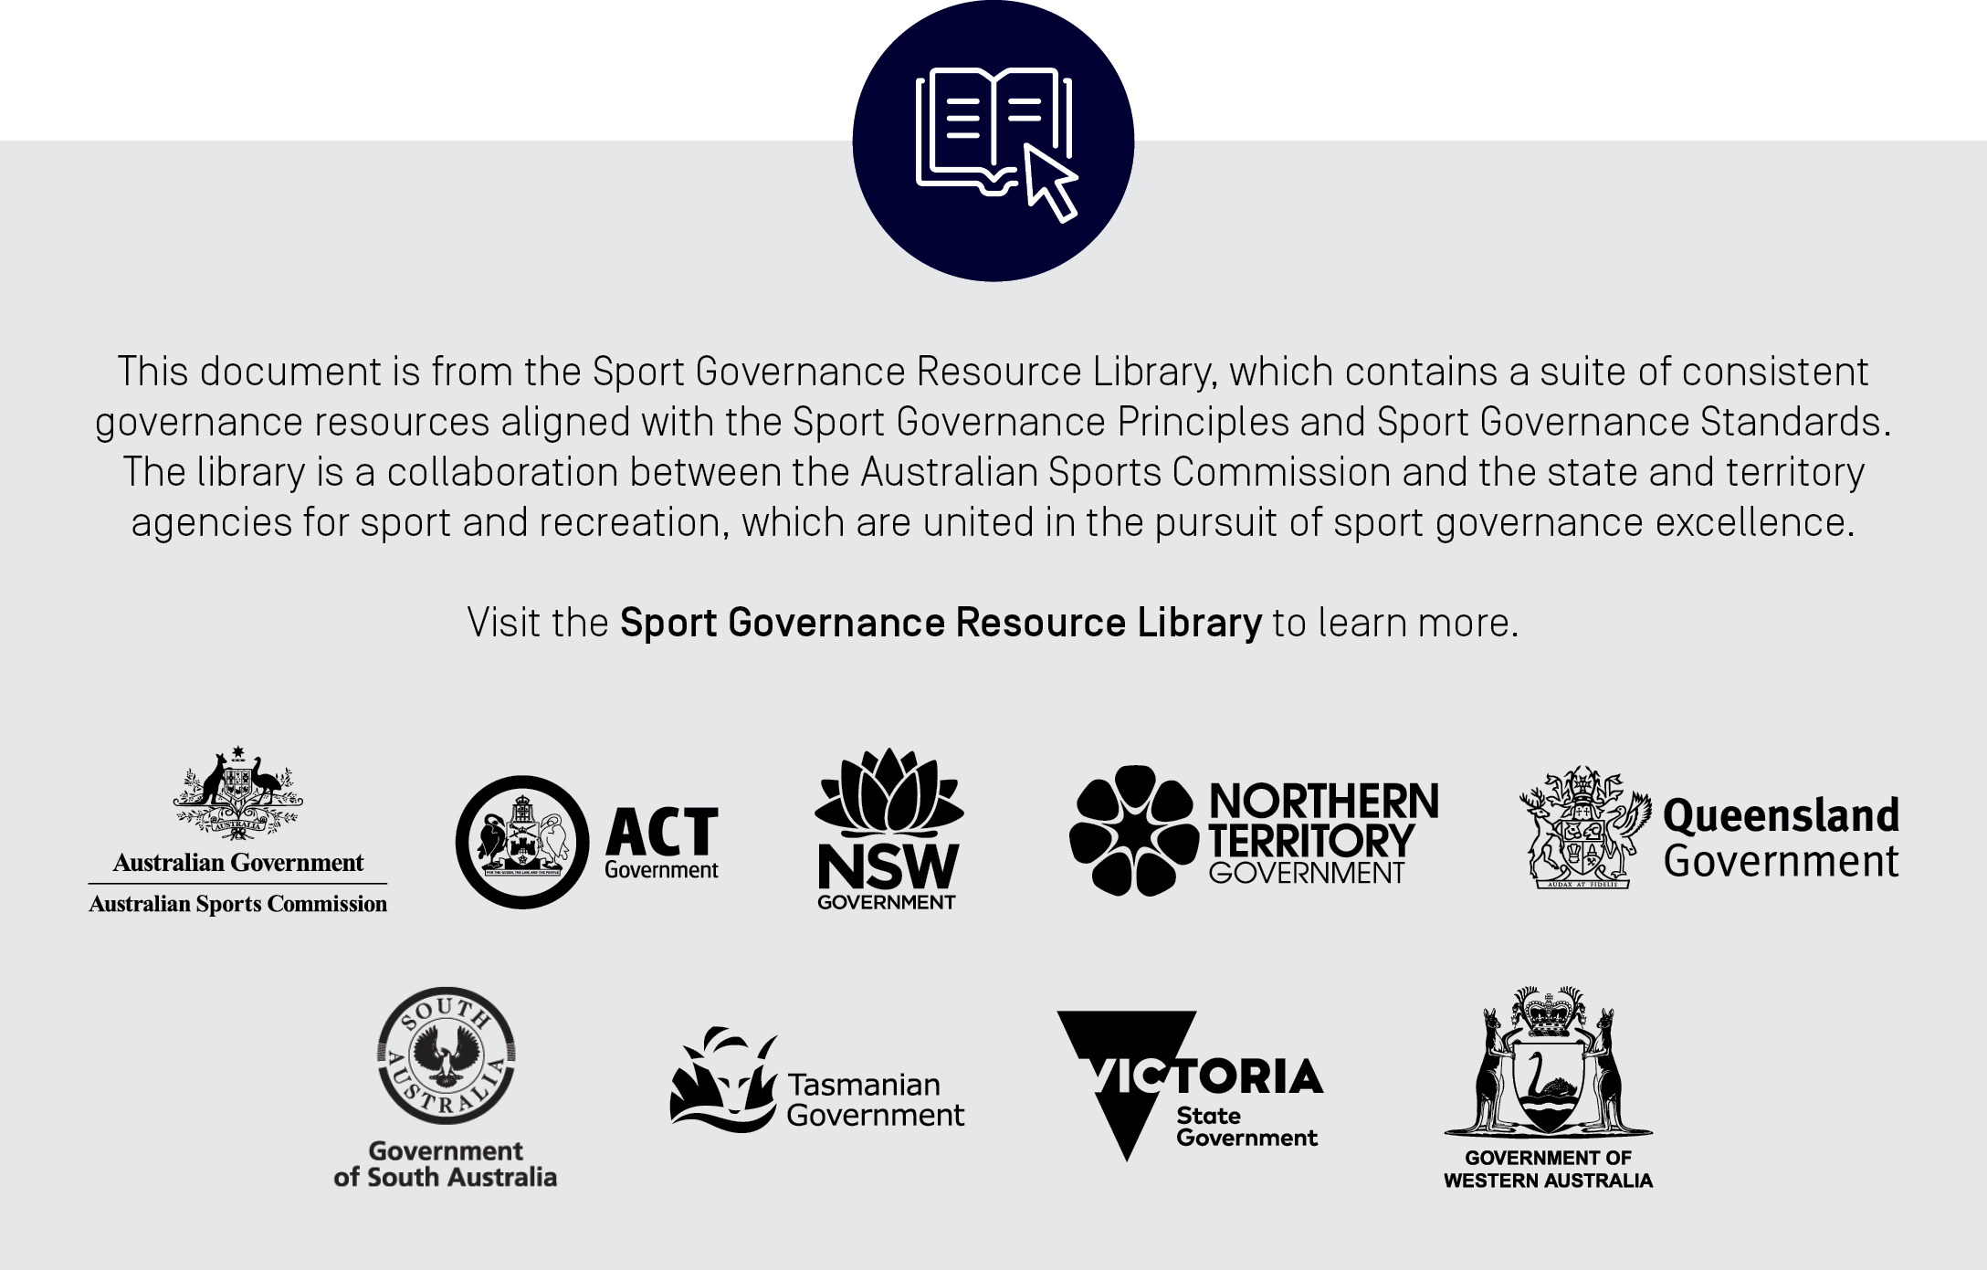

**Notes:**

1. The Board (including via the Audit and Risk Committee) and Management of each Sporting Organisation must receive a basic level of risk reporting to allow each to properly discharge their duties.
2. Regular Board and Management risk reporting should be implemented for all Sporting Organisations to ensure appropriate reporting on:

* key risks and relevant information related to those key risks;
* movement (i.e., increase or decrease) in the rating of key risks;
* details of adequacy of control / mitigation plans;
* issues and breaches arising in the organisation’s management of key risks; and
* overall risk management performance over a defined period (e.g., annual) and any proposals for upgrades to the risk management framework, including the organisation’s risk management policy and risk appetite statement.

1. As the risk maturity of the SO increases so too should the depth of the risk reporting.
2. All reports should highlight the key developments in a Sporting Organisation’s risk profile during the reporting period. These developments can be illustrated using relevant extracts from the Australian Sports Commission risk tools including risk summary reports and risk movements as contained in the risk register.
3. Ultimately it is for the Sport Organisation’s Board to determine what reporting is required as a minimum to discharge its obligation to oversee their risk oversight duties, and what information should be presented within that reporting.

**[Insert ORGANISATION NAME] Board Risk Reporting**

**[ORGANISATION to review and determine appropriate reporting for its own organisational circumstances]**

**Item 1: Risk Update**

The Sporting Organisation’s Management may provide extracts from the organisational risk register to provide an update on material organisational risks.



**Item 2: Risk Rating Movements**

The Sporting Organisation’s management may provide a “Heat Map” to show the distribution of material organisational risks across its risk matrix, including the movement of certain risks during the reporting period.

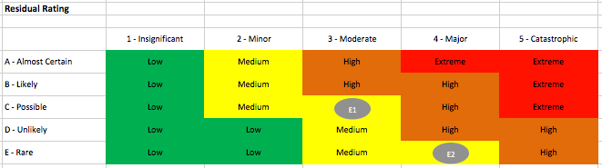

**Item 3: Detailed Risk Reports**

The Sporting Organisation’s Management can use the following “Risk on a Page” report to provide additional detail regarding material organisational risks such as those rated by the Sporting Organisation as “High” and “Extreme”.



**Item 4: Reporting Review**

The Risk Management reporting framework and report templates should be reviewed and approved annually by the [Audit and Risk Committee and] the Board.