Not for Profit Statement

Background
From time to time sporting organisations are required to provide a statement confirming their not-for-profit status. Examples of circumstances where such a statement is necessary include for the procurement of not-for-profit pricing (such as for software), for venue hire and for potential sponsors and donors.

Whilst an organisation’s constitution often contains a clause relating the distribution of organisational equity upon winding-up and occasionally details how surpluses are directed, sporting organisations may find it useful to prepare a stand-alone statement detailing their not-for-profit status.

Purpose
This template outlines the relevant not-for-profit law in Australia and provides an editable template which enables sporting organisations to insert their specific information and to produce a not-for-profit statement.

How to use this document
- This document has been designed as a template. Fields highlighted in yellow should be filled out with the information relevant to your organisation.
- Please note that this guidance and template are general in nature and must be tailored to the requirements of your sporting organisation.
- This document does not constitute legal advice and should not be relied upon as legal advice. We recommend seeking further professional advice should you have any specific queries.

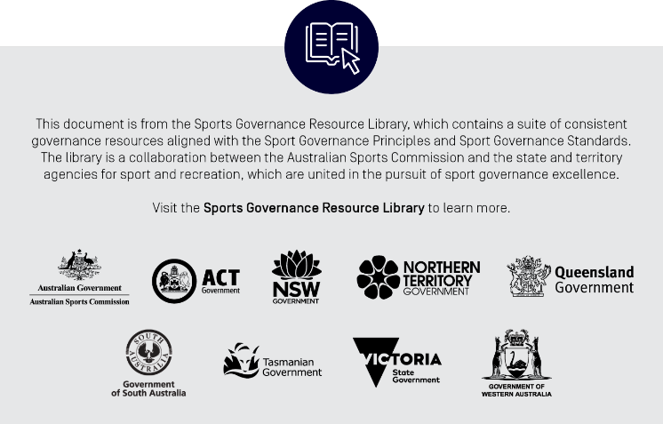

[insert ORGANISATION NAME] as a not-for-profit
Background

[Insert sport name] (Organisation) is the sporting organisation for the sport of [insert] in [jurisdiction].

The primary governing document of the Organisation is its Constitution, which is available here.
Not-for-profit law in Australia

Under Australian law, societies, associations and clubs established for the encouragement of a game or sport are entitled to annually self-assess as a not-for-profit organisation. Where an entity does so, its ordinary and statutory income is exempt from income tax.

There is currently no requirement to register or notify the Australian Tax Office where an Australian sporting body self-assesses as a not-for-profit. Similarly, there is no public register or list outlining the sporting bodies that have self-assessed as a not-for-profit.

To self-assess as a not-for-profit under Australian law, a sporting body must have a physical presence in Australia, comply with all the substantive requirements in its governing rules (the Constitution) and apply its income and assets solely for the purposes for which the entity is established.
Organisation operating as a not-for-profit

The Organisation’s registered office is in Australia.

Under clause:

[#] of its Constitution, the Organisation’s objects are to conduct, encourage, promote, advance, control and manage the Sport in its jurisdiction;

[#] of its Constitution, the income and property of the Organisation must be exclusively applied towards the promotion of its objects; and

[#] of its Constitution, the Organisation must distribute any surplus assets on winding up to another not-for-profit organisation with similar objects to the Organisation.

As a result of paragraphs 6 and 7, the Organisation is entitled to, and does, self-assess as a not-for-profit under Australian law.
Further information

If you require further information regarding the Organisation’s not-for-profit status, please contact [insert contact].
*****
[insert Sport name]
[insert date]

Sections 50.1, 50.45 and 50.70 of Subdivision 50-A of the Income Tax Assessment Act 1997 (Cth).

