[Insert ORGANISATION Logo]

[INSERT ORGANISATION NAME]
RISK MATRIX

Version: | 1.0
Date Adopted by [INSERT ORGANISATION NAME] Board: | [ ]
Effective Date: | [ ]
Review Frequency: | [Annual]
[Insert role title] is responsible for this document.

Template Instructions
- The Australian Sports Commission has developed a range of template documents that can be used by a Sporting Organisation to form a Risk Management Framework.

- This Template document should be read in conjunction with the ‘Risk Management Process Implementation Guide’ for Base Level Risk Maturity.

- This Risk Matrix template is used during risk assessments to express the level of risk attributable to a particular event, considering the relationship between probability/likelihood and the gravity of a consequence/impact. Risks rated accurately and consistently assist management to better prioritise their efforts.

- Yellow highlighting within [ ] brackets indicates further information is required from the Sporting Organisation prior to finalising and adopting the template. Before finalising, insert relevant information where highlighted in yellow and delete these template instructions and the recognition logo below.

- DISCLAIMER: This template does not constitute legal advice. Sporting Organisations should take their own professional advice regarding the Risk Management Framework and each template document.

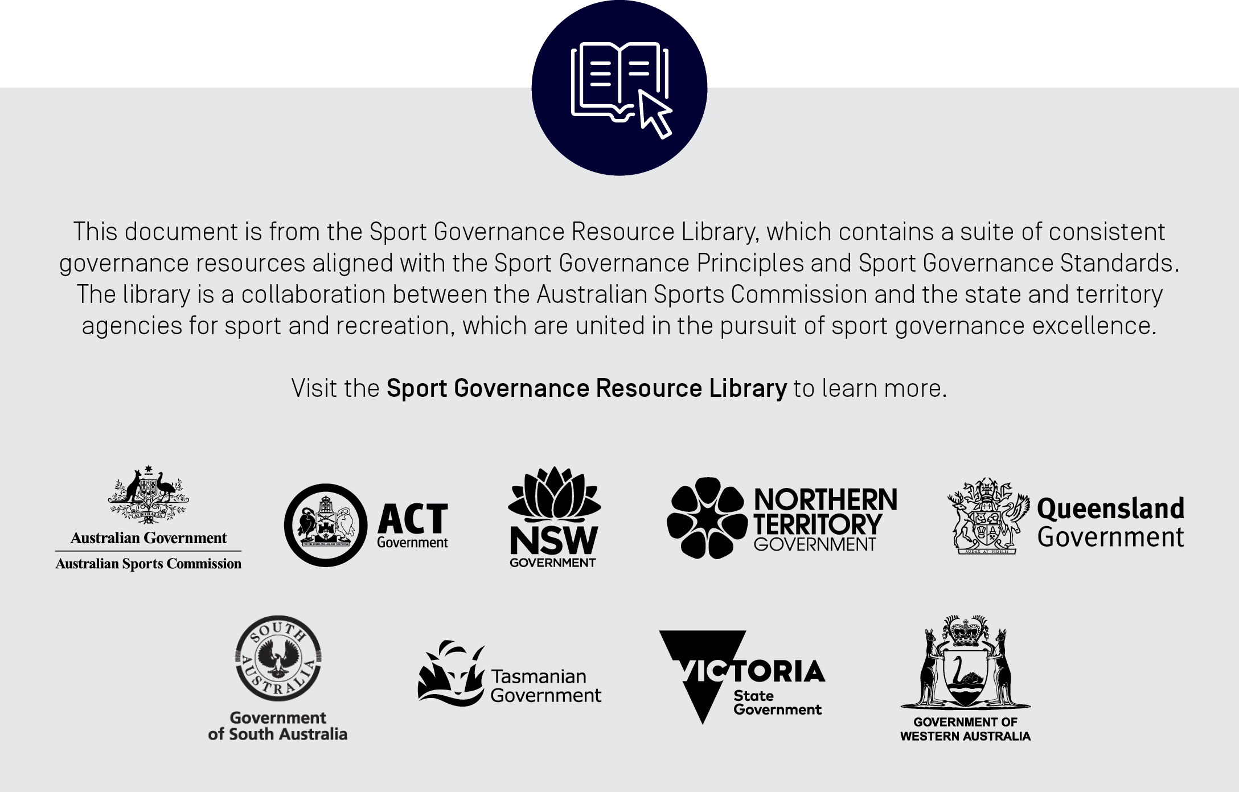
Table 1: Risk Likelihood Ratings [organisation to review]

Level | Rating | Criteria
A | Almost Certain | - Is almost certain to occur  - Risk has more than 75% chance of occurring  - Will occur in the next 6 months
B | Likely | - The event will probably occur more than once  - Risk has 50-74% chance of occurring  - Will occur within 18 months
C | Possible | - The event might occur at some time  - Risk has 25-49% chance of occurring
D | Unlikely | - Could occur at some time  - Risk has less than 25% chance of occurring  - Will occur within 54 months
E | Rare | - The event may occur only in highly exceptional circumstances  - Not likely to occur within next 5 years

Table 2: Risk Assessment Matrix
Consequence
Likelihood |  | 1:  Insignificant | 2:  Minor | 3:  Moderate | 4:  Major | 5:  Catastrophic
 | A: Almost Certain | Low | Medium | High | Extreme | Extreme
 | B: Likely | Low | Medium | High | High | Extreme
 | C: Possible | Low | Medium | Medium | High | Extreme
 | D: Unlikely | Low | Low | Medium | High | High
 | E: Rare | Low | Low | Medium | Medium | High

[INSERT ORGANISATION NAME] Risk Matrix

Table 3: Consequence Descriptors [organisation to review]

Rating | Financial | Reputational | Corporate | Legal & Compliance | People
Catastrophic | Financial impact / opportunity cost greater than [insert value] | - Long term damage to reputation/brand of [insert organisation and/or key insert organisation team(s)]  - Continuous, sustained [greater than 6 months] and universal negative media coverage  - Actions of individuals or the organisation resulting in loss of:  - [major sponsor(s)]  - [significant government or other funding] | - Full loss of office/key facility(ies) for [insert timeframe]  - Full loss of server/s  - Loss of customer facing system for [insert timeframe]  - Loss of internal business critical system for [insert timeframe] | - Litigation with uninsured costs, damages or regulatory fine of greater than [insert value here]  - Jailing of director, officer or employee for organisation-related issue  - Successful litigation against [insert organisation] for negligence relating to athlete injury  - Proven corruption or doping violation involving multiple organisation personnel | - Single sport/tour related fatality of organisation personnel  - Australian athlete strike  - Significant widespread disengagement and loss of morale resulting in:  - Key resignations  - [insert relevant HR metrics]
Major | Financial impact / opportunity cost between [insert values] | - Significant damage to reputation/brand of [insert organisation and/or key insert organisation team(s)]  - Continuous adverse [between 1 and 6 months] media coverage  - Adverse media coverage resulting in:  - [[X%] decline in season attendance]  - [[X%] decline in season registrations]  - Actions of individuals or the organisation resulting in loss of [material] funding source  - Sustained poor performance of elite team(s)/athlete(s) | - Loss of office/key facility(ies) for [insert timeframe]  - Loss of customer facing system for [insert timeframe]  - Loss of internal business critical system for [insert timeframe]  - Extensive management involvement and moderate cost to restore critical processes | - Major systemic, recurring or significant breaches of contract or regulation  - Litigation with uninsured costs, damages or regulatory fine of between [insert values]  - Prosecution of director, officer or employee for ORGANISATION-related issue  - Significant litigation involving full-time legal resource for greater than [insert timeframe]  - Proven corruption or doping violation involving single organisation personnel | - Multiple serious sport/tour related injuries resulting in permanent disability to organisation personnel  - Widespread disengagement and loss of morale resulting in:  - High staff turnover  - [insert relevant HR metrics]
Moderate | Financial impact / opportunity cost between [insert values] | - Moderate damage to reputation/brand of [insert organisation and/or key insert organisation team(s)]  - Adverse media coverage resulting in:  - [[X%] decline in season attendance]  - [[X%] decline in season registrations]  - Actions of individual or the organisation resulting in loss of funding source  - One-off poor performance of elite team(s)/athlete(s) | - Loss of office/key facility(ies) for [insert timeframe]  - Loss of customer facing system [insert timeframe]  - Loss of internal business critical system [insert value] | - Serious breach of contract or regulation with investigation, renegotiation or report to authority with damages, prosecution and / or moderate fine possible between [insert value here]  - Litigation involving full time legal resource for greater than [insert timeframe]  - Systemic non-compliance by the business | - Serious tour related injury resulting in temporary disability to organisation personnel  - Serious but short-term loss of morale and disengagement resulting in:  - [insert relevant HR metrics]
Minor | Financial impact / opportunity cost between [insert values] | - Low-level damage to reputation/brand of [insert organisation and/or key insert organisation team(s)]  - Actions of individual or organisation resulting in:  - [[X%] decline in season attendance]  - [[X%] decline in season registrations] | - Loss of customer facing system [insert timeframe]  Loss of internal business critical system [insert timeframe] | - Minor legal issues, non-compliance and/or breach of regulation or contract  - Low range exposure less than [insert value]  - Litigation involving less than [insert timeframe] full time legal resource  - Sanctioning of several [insert organisation] athletes for on-field misdemeanour in same tournament / match | - Minor to moderate tour related injury with no disability  - Noted disengagement and loss of morale resulting in:  - [insert relevant HR metrics]
Insignificant | Financial impact / opportunity cost less than [insert value] | - Limited adverse publicity [1 – 2 days]  - No measurable impact on attendances or registrations | Service standards not achieved but no impact on business-critical functions | - Sanctioning of athlete for low-level on-field misdemeanour | Short term disengagement, localised loss of morale

